**Course: Advance Bio Informatics**

**Module Title: Pharmacogenomics Applications**

**Module No: 117**

**Pharmacogenomics**

How genes affect persons response to drugs?

It is combination of two words

**(i)** Pharmacology (science of drugs)

**(ii)** Genomics (the study of genes and their functions).

Pharmacogenomics (a portmanteau of pharmacology and genomics) is the study of the role of genetics in drug response. It deals with the influence of acquired and inherited genetic variation on drug response in patients by correlating gene expression or single-nucleotide polymorphisms with drug absorption, distribution, metabolism and elimination, as well as drug receptor target effects. The term pharmacogenomics is often used interchangeably with pharmacogenetics. Although both terms relate to drug response based on genetic influences, pharmacogenetics focuses on single drug-gene interactions, while pharmacogenomics encompasses a more genome-wide association approach, incorporating genomics and epigenetics while dealing with the effects of multiple genes on drug response.

Pharmacogenomics aims to develop rational means to optimize drug therapy, with respect to the patients' genotype, to ensure maximum efficacy with minimal adverse effects. Through the utilization of pharmacogenomics, it is hoped that drug treatments can deviate from what is dubbed as the “one-dose-fits-all” approach. It attempts to eliminate the trial-and-error method of prescribing, allowing physicians to take into consideration their patient’s genes, the functionality of these genes, and how this may affect the efficacy of the patient’s current and/or future treatments (and where applicable, provide an explanation for the failure of past treatments). Such approaches promise the advent of "personalized medicine"; in which drugs and drug combinations are optimized for each individual's unique genetic makeup. Whether used to explain a patient’s response or lack thereof to a treatment, or act as a predictive tool, it hopes to achieve better treatment outcomes, greater efficacy, minimization of the occurrence of drug toxicities and adverse drug reactions (ADRs). For patients who have lack of therapeutic response to a treatment, alternative therapies can be prescribed that would best suit their requirements. In order to provide pharmacogenomic-based recommendations for a given drug, two possible types of input can be used: genotyping or exome or whole genome sequencing. Sequencing provides many more data points, including detection of mutations that prematurely terminate the synthesized protein (early stop codon).

Ultimate aim is to develop effective, safe medications & doses tailored to a person's genetic makeup.

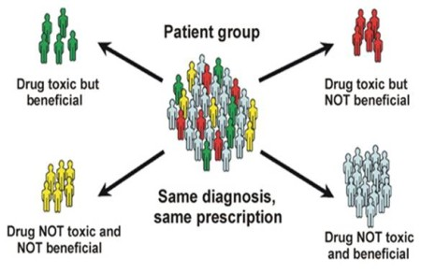

**Pharmacogenomics Applications:**

* Improve drug safety
* Reduce ADRs
* Tailor treatments to meet patient’s unique genetic redisposition,
* Optimal dosing
* Improve drug discovery
* Improve proof of principle for efficacy trials.

**Future**

Blessing in research. As a simple example, for nearly a decade the ability to store more information on a hard drive has enabled us to investigate a human genome sequence cheaper.